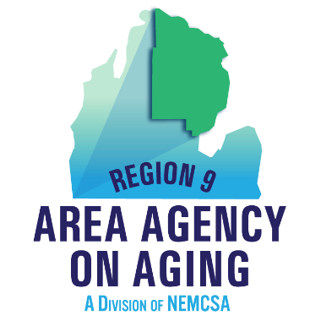

Region 9 Area Agency on Aging Goals
Taken from the Program Development Objectives for FY 2022

- Advocate for senior programs and engage in dialog with the aging network constituents and elected officials.

- Promote caregiver wellness and empowerment by providing education to enhance the caregiver experience.

- Increase capacity to provide non-emergency medical transportation within the PSA.

- Expand opportunities for seniors to participate in Evidence-Based Disease Prevention (EBDP) programs.

- Promote independent living and self-choice in developing care programs by offering long-term supports and services.

- Provide education on Medicare and Medicare Fraud awareness.

- Increase public awareness of signs of abuse, neglect and financial exploitation among senior populations.

- Foster development of new collaborations and enhance current partnerships to build the aging continuum.

- Improve the quality and effectiveness of services provided through the regional aging network and Region 9 Area Agency on Aging partners.

